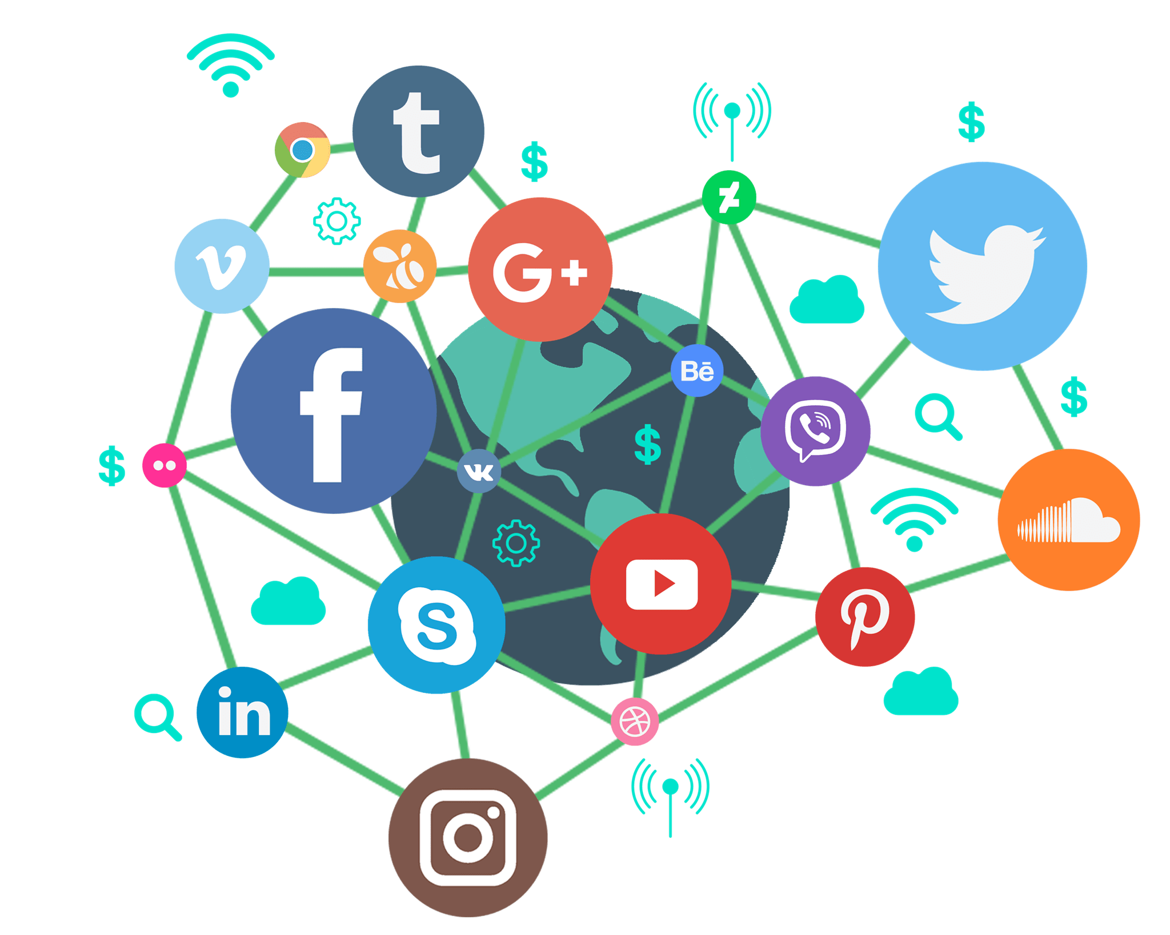A social media, according to Merriam-Webster (2021), is an internet platform hosted by a private company that allows users/customers to join in order to communicate with friends, express ideas, share multimedia, and join online communities. Because of their involvement in both personal and private life, social media as a technology features many choices, opportunities, and risks. The choices afforded by social media includes data, targeted advertising, and free communication. Social media companies can provide many different opportunities for businesses, individuals and education providers. Platforms also have a lot of power, which brings the risk of privacy, production loss and even vigilantism.

The choices a social media company/platform can have requires a careful balancing act of need and want. One choice a social media company has is data. Data is to social media like butter is to bread. Without data a social media cannot bloom full of users and communities, but, how much data should a social media company have? It’s easy to say they should only keep important user data like name, age, and email address but there is other data such a user posts, multimedia, friends, groups, posts they liked, links they’ve clicked, number of followers, previous internet activity, etc. Another choice data gives is how to store and display this data. On the computers of users in fragmented chunks, privately owned servers, amazon web services servers, or multiple servers around the world. When displaying data should images and videos be shown one by one, in collages, with text, should edges be rounded, should they expand when the mouse hovers over them? With data, there are many small choices that ultimately build up to a platform’s entire design methodology and mission statement. When working with data it is important for a business to secure that data and to also inform users on what data they are collecting. The New Zealand privacy commissioner says “Under the privacy act agencies organizations and businesses have to respect your personal information, which is any information that can identify you as an individual. This can include but is not limited to your name, your address, a picture of your face, a record of your opinion and views, employment information, health records, and financial information.” It is also a requirement of agencies that they keep personal information for no longer than is necessary and is only stored if it is necessary. These legal expectations for businesses ensure the protection of individuals personal information and private data.

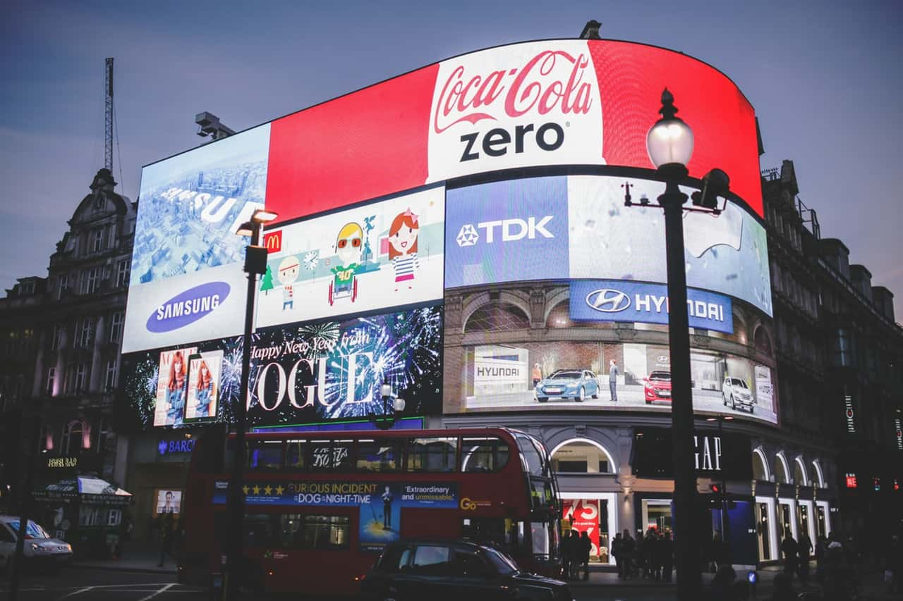

Another choice afforded by social media is targeted advertising. Targeted advertising relies on tracking user activity and then displaying advertisements for products or services that relate to said activity. While targeted advertising is not necessarily exclusive to social media, it is widely accepted that because social media has far more access to personal and private information it can use the information it collects to advertise to specific audiences and consumers far more efficiently than any other platform. This power to advertise directly to consumers based on what is known about them opens up a gradient of choices, from the darkest choice being complete collection of data and constant advertising to the lightest choice which would be no tracking and randomly distributed ads. Most companies sit in the Gray area where they will always try to preserve privacy while also maintaining a minimum level of tracking in order to provide more relevant advertisements. Whether or not a company is tracking too much or too little is a nuanced question and can only be answered from person to person on a case by case basis. I attempted to find data on how much social media companies track users in order to plot them on a black to white gradient, but unfortunately was unable to find such data, but, I did come across a Forbes article that teased my futile efforts titled “Social media companies collect so much data even they can't remember all the ways they surveil us” by Kalev Leetaru (2019). The choice to track user information in order to advertise directly to consumers 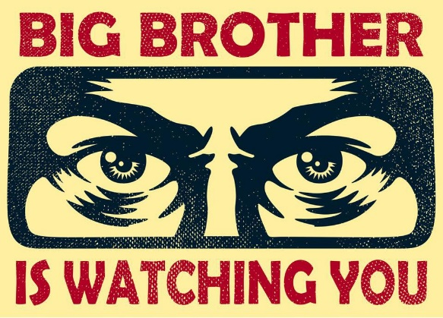can be a double-edged sword. To consumers it can be detrimental to mental health knowing that all your data is being used to target you and your wallet, but, it could also be seen as a positive by both consumers and businesses as more relevant advertisements are being shown to the people who need to see them the most. Nevertheless, whether tracking user data to provide targeted advertisements is good or bad is irrelevant. The power is in the hands of social media companies and developers to use the powers they have in a way that they see most responsible.

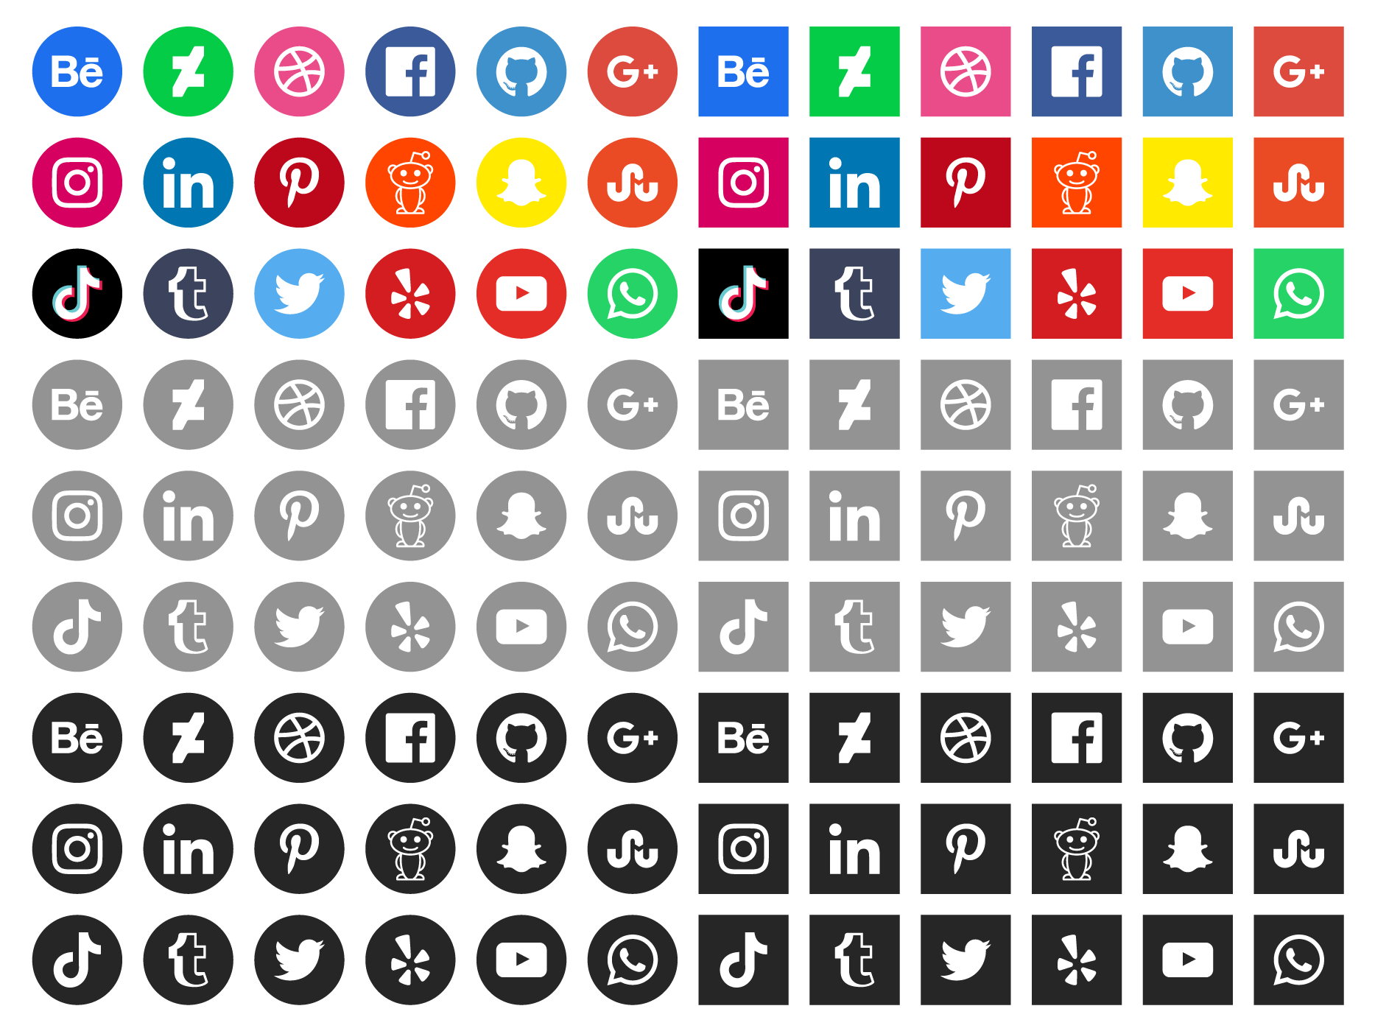A critical and obvious choice brought about by social media is often overlooked, that of course being free communication. Because the Internet is an open interconnect of systems that isn't owned by anyone, the ability to produce and create your own social media has never been easier. Because of this, the social media industry is filled to the brim with different choices. This seemingly limitless amount of choice gives the users the freedom to select which platform they prefer. Free choice for the consumers method of communication and the competition between social media companies to produce the best methods of communication lead to the creation of highly polished websites and applications that better serve the users. This creation of highly polished websites and applications leads to the furthering of technology as a whole that pushes more competition more choice for users and ultimately creates a feedback loop that continuously attempts to improve technology further and further. This is a simple reason as to why technology has moved so quickly over the past decade. Ultimately, social media platforms are created for the users that use them. Without users and customers, social media platforms cannot exist. Because of this fact, ultimately, consumers have the most choice when it comes to social media, but, it is up to them as to whether they use their free will or not.

